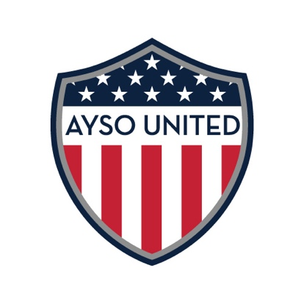
AYSO United Parent Code of Conduct

As the parent of an AYSO soccer player, I represent the club whenever I am at any event in which AYSO United teams participate. I understand and agree to the following rules and guidelines below and I take responsibility for all persons within my party or group.
1. I am a representative of AYSO United Soccer Club. My demeanor both on and off the field is a reflection of our club. Poor sportsmanship and inappropriate behavior will not be tolerated and will result in a suspension for me from club events. ____
2. It is my responsibility to ensure my child/children arrive at all AYSO United events, practices and games at the designated time. ____
3. At no time will I use threats, violent force, obscene or abusive language toward any coach, player, spectator, or referee. I understand that failure to comply will result in suspension for me and can result in my child being asked to leave the club. ____
4. I will NOT speak or gesture in any manner to any referee or official during the game. I will respect the decisions and judgments made by the referee. Mistakes will be made, but this is a game. ____
5. During the game, I will refrain from coaching from the sideline. I will support my child and team by only cheering in a polite manner. I will not scream or gesture in any profane manner. I will leave the coaching to the coaches. ____
6. During the game, I will not to speak to the players from the other team unless I am CLEARLY commenting on a good play that they have made. Even though I may know the player on the other team, I realize the referee, coaches and other parents may not know my relationship with an opposing player. ____
7. I will never ridicule or yell at any child. This includes my own child, my child’s team mate, or an opposing player. ____
8. I understand that the use of alcohol is strictly prohibited at any AYSO event that the children participate in unless otherwise notified. I also understand that smoking is prohibited on the fields and venues that we play in and may not be done in direct proximity of the children. ____

9. I understand that AYSO United coaches are experienced, volunteer coaches. Any disagreement regarding coach's decisions or methods should be discussed privately with the coach not less than 24 hours after the incident and in an adult manner. If you feel this may intensify the problem, you may discuss the matter with either the President or the Director of Coaching. Confrontations or threats toward the coaches will not be tolerated. ____
10. I understand that the head coach is responsible for the actions of his or her players, parents, and assistant coaches. They are expected to maintain order on both sidelines. Failure to maintain order could result in a suspension for my coach. ____
11. I understand that at no time am I allowed onto the field of play or allowed to stand and watch a game from behind the goal line. This especially applies to instances where a player is injured on the field. Once the referee recognizes an injured player, he or she will stop play, assess the extent of the injury and will either summon the coach onto the field or resume play. I will not enter the field of play unless authorized by either coach or referee to do so. ____
12. I understand that the governing bodies that AYSO United operates under and with, have rules about recruiting players. It is the responsibility of all AYSO United parents and players to inform the Director of Coaching of any approach made to them from another club or team. Movement between teams is subject to recommendations made by the coaches and a final decision made by the Director of Coaching. Any attempt to unsettle players within AYSO United by offering them positions on other teams, whether within AYSO United or in another club will be reported to the appropriate governing body and, if necessary, will be dealt with internally by the club. Actions such as this may ultimately lead the offending party being asked to leave the club. ____
The Club may issue suspensions to parents that do not abide by the club’s parent code of conduct.
For more information on AYSO philosophies, parent education or player development, go to ayso.org
I have read and understand this code of conduct. I will abide by the guidelines and do my best to uphold the AYSO philosophies of good sportsmanship, positive coaching and player development. __________________________________________________

Thank you.
AYSO United Hill Country

